

**Final Year Project Proposal**

**Group Members:**

Muhammad Wahaj Bin Aamir (13472) (Team Leader)

Muhammad Arees Naseer Khan (13793)

Tooba Jameel (13435)

Taha Aslam (13794)

**Project Supervisor:**

Sir Engr. Ghalib Nadeem

**Project Title:**

**Enhancing Airport Security Management through Real-time Computer Vision: An AI-Powered Anomaly Detection System**

**Abstract:**

This proposal presents an advanced real-time computer vision system aimed at enhancing airport security management through the integration of AI-powered anomaly detection. Leveraging deep learning and convolutional neural networks (CNNs), the system aims to detect anomalies such as non-attendant material, unauthorized personnel in a no-go area, variations in light intensity, traffic in lines, wet carpets, broken tiles and garbage overflow. By promptly notifying management of detected anomalies, the system facilitates proactive action within existing regulations and protocols. Furthermore, the methodology involves rigorous data collection, model development, integration, testing, and deployment to ensure the system's accuracy and reliability. This comprehensive approach significantly improves airport security and management through automated surveillance capabilities and timely intervention to mitigate security risks.

**Introduction:**

Efficient monitoring systems are vital for ensuring the safety of passengers, staff, and infrastructure within airports. However, traditional manual inspection methods often fall short in detecting subtle anomalies, highlighting the pressing need for automated solutions capable of real-time anomaly detection. In response to this challenge, this proposal introduces an innovative computer vision system augmented with AI-powered anomaly detection capabilities.

This system aims to enhance existing security measures by providing automated, continuous, and real-time surveillance capabilities. By leveraging cutting-edge AI technology, including deep learning and convolutional neural networks, the system can swiftly detect anomalies such as unattended items, unauthorized personnel in restricted areas, variations in light intensity, traffic in boarding lines and environmental hazards like wet carpets, broken tiles and filled garbage bin. Prompt detection of such anomalies allows for proactive interventions within established regulatory frameworks, significantly enhancing airport security protocols.

Relevant industry research, such as Hitachi's collaborative endeavors in improving surveillance efficiency [1], underscores the feasibility and effectiveness of integrating advanced computer vision technology into airport security management. For instance, Hitachi's development of solutions for unattended baggage detection, based on image analysis and real-time tracking, serves as a compelling example of how AI can enhance security operations in high-traffic environments.

**Problem Statement:**

Despite robust security protocols, airports face multifaceted challenges that compromise safety and operational efficiency. Issues such as unattended baggage, unauthorized personnel in restricted areas, and irregular passenger flows are compounded by less obvious yet critical anomalies like wet carpets, overflowing garbage bins, broken tiles, variations in light intensity, and the management of long queues. These problems highlight the limitations of traditional, labor-intensive monitoring systems, which are not only prone to human error but also often fail to address a comprehensive range of airport safety and security concerns. There is a compelling need for an automated, AI-powered computer vision system that can detect and respond to these diverse issues promptly and accurately, thereby enhancing overall airport security and operational efficiency, and supporting security personnel in upholding stringent safety standards.

**Filled Garbage Bins:**

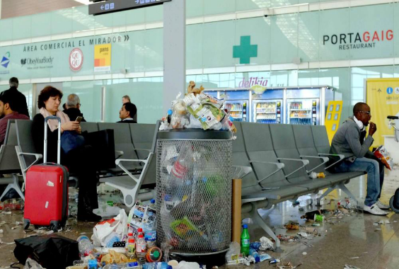 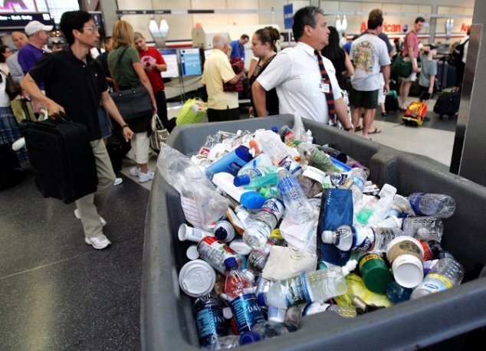

**Figure 1 Figure 2**

**Traffic In Lines:**

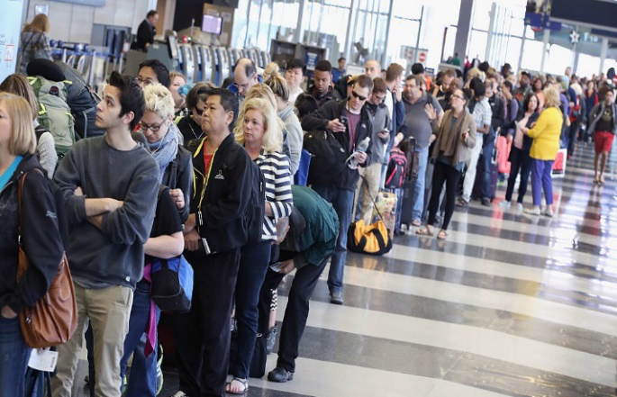 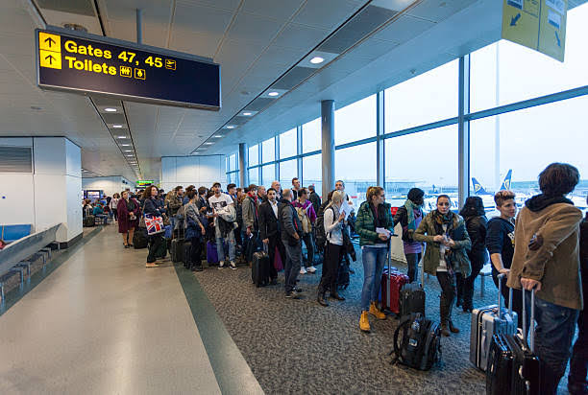  
 **Figure 3 Figure 4**

**Un-attended Luggage:**

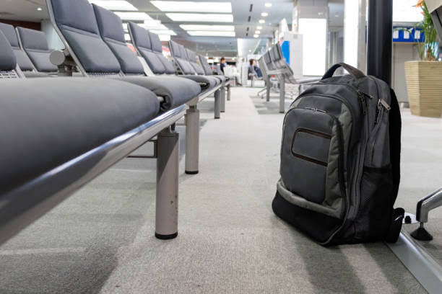 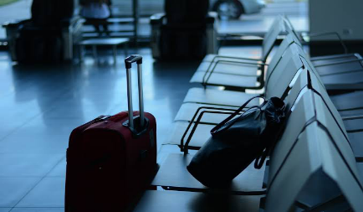  
 **Figure 5 Figure 6**

**Variation in Light Intensity:**

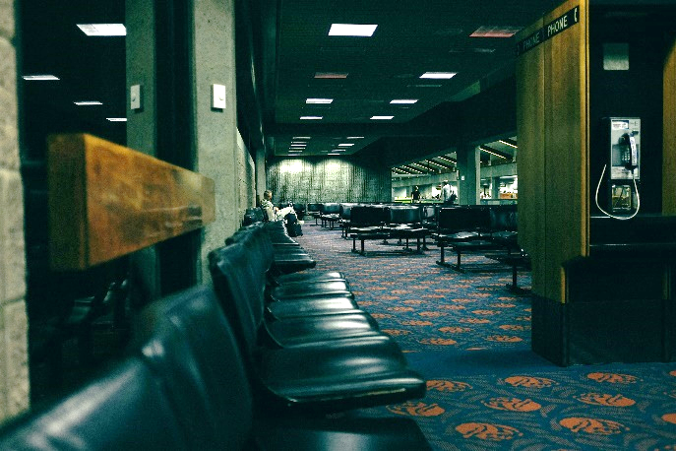 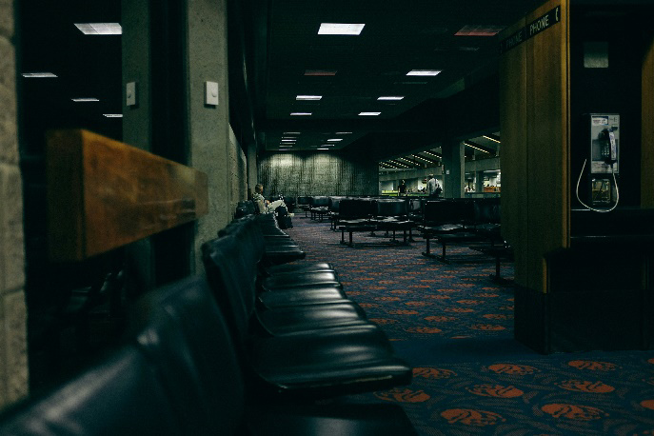

**Figure 7 Figure 8**

**Wet Carpets:**

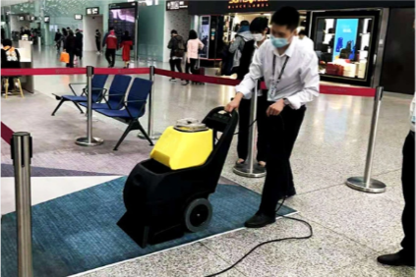 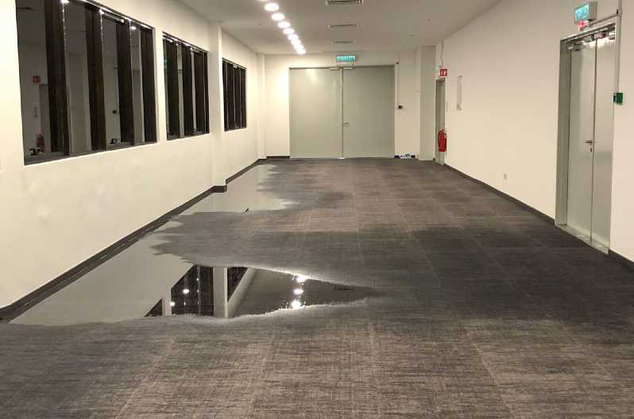

**Figure 9 Figure 10**

**Unauthorized Personnel In A No-Go Area:**

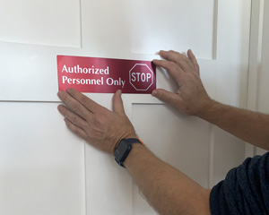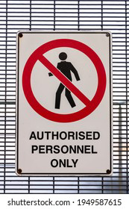

**Figure 11 Figure 12**

**Broken Tiles:**

 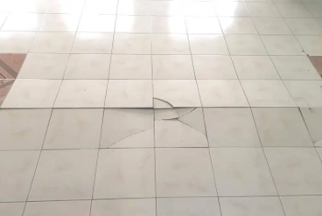

**Figure 13 Figure 14**

**Proposed Solution:**

The proposed solution integrates AI-powered or local cameras with deep learning models, particularly convolutional neural networks (CNN), for real-time anomaly detection. The system is trained on labeled datasets to accurately detect various anomalies and deviations. Once anomalies are detected, the system generates alerts to notify administrators, facilitating timely intervention and ensuring compliance with existing regulations. Research indicates that these systems can enhance the effectiveness of surveillance operators, although further improvements are necessary. Practical tests conducted at Katowice-Pizovice International Airport underscore the importance of maintaining robust security measures at critical infrastructure sites like international airports [2].

**Methodology:**

1. **Data Collection and Preparation:** Gather labeled datasets encompassing diverse anomalies relevant to airport management.
2. **Model Development:** Design and train CNN-based models for anomaly detection, focusing on accuracy and real-time performance.
3. **Integration:** Integrate the developed models with AI-powered or local cameras deployed strategically across the airport premises.
4. **Testing and Validation:** Conduct rigorous testing to evaluate the system's performance in detecting anomalies accurately and promptly, starting with simulated environments followed by real-world pilot testing in selected airport zones.
5. **Deployment:** Deploy the finalized system within modern Airport Management Systems, ensuring seamless integration and compatibility.

**Conclusion:**

In summary, this project presents a proactive strategy to enhance airport security management through the deployment of a real-time computer vision system. By leveraging AI-powered anomaly detection and rigorous testing methodologies, the proposed solution aims to address longstanding challenges in airport surveillance, including unattended baggage, unauthorized access, and environmental hazards. Through seamless integration into existing infrastructure and continuous monitoring capabilities, this project seeks to elevate safety standards and operational efficiency in international airports, ensuring a secure and reliable travel experience for passengers and staff alike.

**References:**

**[1]:** AI-based Video Analysis Solution for Creating Safe and Secure Society. Hitachi <https://www.hitachi.com/rev/archive/2020/r2020_05/05b06/index.html>+

**[2]:** Artificial Intelligence Systems for Supporting Video Surveillance Operators at International Airport. Procedia Technology <https://www.sciencedirect.com/science/article/pii/S2352146523005707>

**Figure 1:** "Restos de basura en la T1 del Aeropuerto de Barcelona." by Toni Albir, sourced from Cadena SER (<https://cadenaser.com/emisora/2016/12/02/radio_barcelona/1480681514_949641.html>)

**Figure 2:** "Discarded items no longer allowed on planes, including bottles of water, deodorant, shampoo and toothpaste, fill a trash container near the American Airlines ticket area in Terminal 1 at O'Hare International Airport in Chicago." by Tim Boyle / Getty Images, sourced from NBC News (<https://www.nbcnews.com/id/wbna14308565>)

**Figure 3:** "As Long Lines In Airports Rise, TSA Struggles To Cut Waiting Times" by Scott Olson / Getty Images, sourced from Getty Images (<https://www.gettyimages.com/detail/news-photo/passengers-at-ohare-international-airport-wait-in-line-to-news-photo/531740056?adppopup=true>)

**Figure 4:** "A catastrophic disaster for the aviation industry" by crossbrain66 | iStock, sourced from Open Access Government (<https://www.openaccessgovernment.org/air-traffic-control-glitch-reveals-weaknesses-within-the-aviation-industry/165770/>)

**Figure 5:** "Unattended cabin backpack abandoned on the floor at the boarding waiting hall of an airport." by RUBEN RAMOS, sourced from iStock (<https://www.istockphoto.com/photo/unattended-cabin-backpack-abandoned-on-the-floor-at-airport-gm1187709935-335629630>)

**Figure 6:** "Arrival at the airport" from iLink Tours (<https://www.ilinktours.com/blog/hajj-and-umrah-advice-and-tips-arrival-at-the-airport/amp/>)

**Figure 7 & 8:** Times Now News (<https://www.timesnownews.com/business-economy/industry/article/premium-lounge-to-waiting-room-enjoy-1st-class-facilities-at-this-railway-station/356599>), shared in a video by Piyush Goyal.

**Figure 9:** Made-in-China.com (<https://pivotma.en.made-in-china.com/product/kFmAbfycOarT/China-Three-in-One-Wet-Dry-Carpet-Cleaner-Hotel-Corridor-Cinema-Banquet-Hall-Carpet-Washing-Suction-Integrated-Machine.html>)

**Figure 10:** Steamatic SFV (<https://steamaticsfv.com/water-damage/>)

**Figure 11:** "Authorized Personnel Only Door Signs" by MyDoorSign, sourced from MyDoorSign (<https://www.mydoorsign.com/door-signs/authorized-personnel-only-signs>)

**Figure 12:** Pngtree (<https://pngtree.com/freebackground/authorized-personnel-only-sign-wrong-ban-direction-photo_3454418.html>)

**Figure 13:** “Close-up photo of light gray tile with large diagonal cracks and chips” by Jockermax sourced from iStock.

<https://www.istockphoto.com/photo/close-up-photo-of-light-gray-tile-with-large-diagonal-cracks-and-chips-gm1206304204-347865375?searchscope=image%2Cfilm>

**Figure 14:** “Tile popping – Causes & solutions”, DailyCivil. Retrieved from <https://dailycivil.com/tile-popping-causes-solutions/>